

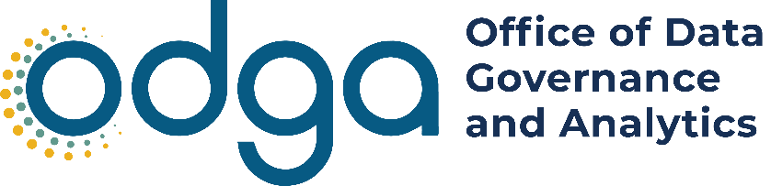

Annual Report 2025
Office of Data Governance and Analytics

Table of contents
Executive Summary 2
Data Governance and Operations 4
Substance Use Disorder Analytics (SUDA) 4
Finance Agency Risk Reduction 5
Virginia Permit Transparency (VPT) 6
Penetration Testing 7
Commonwealth of Virginia Data Catalog 7
Data Management Maturity Assessment (DMMA) 8
Government Data Collection and Dissemination Practices Act (GDCDPA) 8
Data Scanning 10
VEC Fraud Analytics System Hosting 10
Department of Education Chronic Absenteeism Project 11
Boards and Councils 11
Executive Data Board 11
Data Governance Council 12
Data Stewards Group 12
Agency Engagement 13
Lunch and Learns 13
Resource Library 13
Data Literacy Library 14
Data Governance Role-Based Training 15
Knowledge Sharing 15
Data Classification Tool 15
Knowledge Sharing Through Speaking Engagements 16
Data Governance Maturity Contest 17
Commonwealth Data Trust (CDT) 18
Commonwealth Data Trust Portal 18
Commonwealth Data Trust Membership 19
Citizen Engagement 21
Virginia Open Data Portal (ODP) 21
Virginia Datathon 22

Executive Summary
The Virginia Office of Data Governance and Analytics (ODGA) serves as a catalyst for data-driven transformation across the Commonwealth, empowering state agencies and governmental organizations to leverage enterprise data assets strategically. Through collaborative partnerships, technical expertise and adherence to best practices in data governance, ODGA enables agencies to make evidence-based decisions that optimize resource allocation and improve service delivery across all levels of government.
The Office of Data Governance and Analytics (ODGA) submits this report pursuant to § 2.2-203.2:4 (B)(8) of the Code of Virginia, which establishes the position of Chief Data Officer of the Commonwealth and directs the Office to “report on the activities of the Office and the Commonwealth Data Trust annually by December 1 to the Governor and the General Assembly.” The statute outlines the responsibilities of the Chief Data Officer which include: setting data governance standards, facilitating secure and responsible data sharing across state, regional, and local entities, supporting compliance with privacy and data protection laws, and overseeing the Commonwealth Data Trust and the Virginia Open Data Portal. This report details ODGA’s activities, initiatives, and accomplishments over the 2025 calendar year in fulfillment of these duties.
A pivotal milestone occurred in 2025 with ODGA's formal integration into the Virginia Information Technologies Agency (VITA), marking a transformative period in it’s organizational evolution. This strategic consolidation has provided ODGA with enhanced institutional stability, operational maturity and access to enterprise-level support services that were previously unavailable as a standalone entity. This integration has strengthened our foundation across multiple critical business functions, including human resources management, facilities coordination, procurement processes, legal counsel and administrative infrastructure.
The majority of 2025 was dedicated to ensuring seamless organizational alignment with VITA's established frameworks, standard operating procedures and governance structures. Our team worked diligently to preserve ODGA's specialized expertise and service delivery capabilities while adopting VITA's mature operational infrastructure, thereby positioning the office for sustainable growth and enhanced service delivery in subsequent years.
Through these integrated efforts and organizational transformation, ODGA has successfully contributed to VITA's establishment as a comprehensive, effective state technology agency while simultaneously advancing sophisticated data governance and analytics capabilities across the Commonwealth. The synergies created through this integration have amplified our impact, expanded our service offerings and positioned us to tackle increasingly complex data challenges.
In 2025, ODGA served as an instrumental technical partner in the Finance Agency Risk Reduction Project, a high-priority initiative designed to strengthen data security and enhance visibility into sensitive information assets across state finance agencies. ODGA was the technical and data governance lead for the innovative Substance Use Disorder Analytics (SUDA) project, a critical cross-agency initiative addressing Virginia's ongoing opioid crisis through enhanced data integration and analytical capabilities.
As we look toward the future, ODGA remains committed to continuous improvement, innovation and expanded service delivery under the VITA umbrella. ODGA anticipates significant opportunities for growth in emerging areas, such as master data management and enterprise data strategy development. Our vision is to establish Virginia as a national leader in government data maturity, demonstrating how strategic data governance and advanced analytics can transform public sector operations and improve outcomes for all Virginians.

Data Governance and Operations

Substance Use Disorder Analytics (SUDA)
ODGA and VITA partnered with Deloitte and Gartner to develop and deploy the Substance Use Disorder Analytics (SUDA) platform, representing a transformative advancement in Virginia's response to the opioid crisis. This groundbreaking data integration initiative brings together critical information from multiple state agencies into a unified analytical framework, enabling unprecedented insights into substance use patterns and treatment outcomes across the Commonwealth. By consolidating drug case data from the Department of Forensic Science (DFS), addiction treatment services information from the Department of Behavioral Health and Developmental Services (DBHDS), and comprehensive overdose data including fatalities, emergency medical services incidents, naloxone administrations and emergency department visits from the Virginia Department of Health (VDH), SUDA provides state leaders and healthcare providers with a comprehensive picture of Virginia's substance use disorder landscape.
The SUDA platform empowers evidence-based policymaking and targeted intervention strategies by identifying geographic hotspots, tracking emerging drug threats and measuring the effectiveness of prevention and treatment programs. This integrated approach eliminates data silos that previously hindered coordinated responses, allowing stakeholders to identify populations at highest risk, allocate resources more efficiently and connect those experiencing addiction to life-saving services more quickly.
As Virginia continues to confront the devastating impact of the opioid epidemic, the SUDA platform stands as a model of innovative government collaboration and data-driven governance. This initiative demonstrates ODGA and VITA's commitment to leveraging technology and analytics to save lives and strengthen communities across the Commonwealth. Moving forward, the platform will continue to evolve with enhanced predictive analytics capabilities, expanded data sources and improved information sharing with local health departments and community partners. This work ensures the Commonwealth remains at the forefront of evidence-based strategies to combat substance use disorders and protect the health and safety of all Virginians.

Amazon Web Services (AWS) Implementation
ODGA’s technical team played a pivotal role in the successful implementation and delivery of the SUDA project throughout the fiscal year. The team's comprehensive technical leadership encompassed critical infrastructure development, data management and user interface design.
The technical team assumed primary responsibility for orchestrating data collection activities across all participating agencies and partner organizations. This complex undertaking required establishing robust data pipelines and governance protocols to ensure consistent, high-quality information flow throughout the project lifecycle.
In collaboration with VITA and their designated cloud service provider, ODGA successfully architected and deployed a comprehensive three-tier environment infrastructure within Amazon Web Services (AWS). This implementation included fully functional development, testing and production environments, providing the necessary foundation for secure, scalable project operations and ongoing system management.
ODGA delivered a sophisticated .NET-based user portal that serves as the primary interface for end-user engagement with the SUDA project ecosystem. This web-based platform provides authenticated users with seamless access to personalized dashboards and reporting capabilities tailored to their specific authorization levels and organizational requirements.
The portal was engineered using modern development frameworks and designed with cloud-native architecture principles to optimize performance, scalability and maintainability. The application features full integration with Commonwealth of Virginia (COV) enterprise services, including single sign-on capabilities through OKTA identity management, ensuring compliance with state security standards and providing users with a streamlined authentication experience.
This comprehensive technical foundation positions the SUDA project for continued success and scalability in the coming fiscal year.

Finance Agency Risk Reduction
Following an independent security assessment of the Finance Secretariat's security posture, an external consulting firm identified a critical risk: agencies do not understand the full scope of where sensitive data resides within their environment and are unable to fully protect it as a result. In response to this finding, ODGA was designated to lead the remediation effort, leveraging its data governance expertise to strengthen the Commonwealth's information security framework.
ODGA implemented a systematic approach to identify, catalog and classify sensitive data across multiple platforms and file formats, establishing the foundation for enhanced security protocols.

Results Achieved
- Conducted comprehensive scanning of 31 critical sensitive applications using Microsoft Purview
- Identified and classified sensitive data columns within application databases
- Established complete inventory of critical application database tables through discovery, cataloging and curation processes
- Executed agency-wide scanning of file shares to locate sensitive information
- Identified sensitive data within Excel spreadsheets, PowerPoint presentations, PDF documents and other unstructured formats
- Implemented proper data classification protocols to enable integration with VITA's Data Loss Prevention (DLP) security infrastructure
This remediation initiative directly addressed the identified security gaps by providing agencies with comprehensive visibility into their sensitive data landscape. The systematic classification of both structured and unstructured data enables robust protection through automated security controls, significantly reducing the Commonwealth's exposure to data security risks while establishing a scalable framework for ongoing data governance and protection.

Virginia Permit Transparency (VPT)
ODGA played a critical role in the Commonwealth's strategic Virginia Permit Transparency (VPT) initiative, designed to enhance economic development by attracting and retaining skilled workers and businesses through improved regulatory transparency and streamlined permitting processes. This collaborative effort with VITA addressed the longstanding challenge of fragmented permitting information across multiple state agencies, which previously created barriers for businesses seeking to understand and navigate Virginia's regulatory landscape. ODGA was specifically engaged to architect and implement the data infrastructure and visualization components of this transformative one-stop-shop platform, developing 17 comprehensive dashboards that serve agencies across the Commonwealth while providing unprecedented public access to permitting information. The ODGA team was responsible for replicating Department of Environmental Quality-specific VPT Tableau dashboards into Power BI. This initiative helped reduce licensing costs and leverages the capacity of the Power BI Service, which is the preferred platform at the enterprise level within the Commonwealth.
The VPT platform represents a significant achievement in inter-agency collaboration and data integration, consolidating permitting processes and information from 10 state agencies onto a unified digital platform. Through a single, user-friendly interface, residents and businesses can now access comprehensive permitting information from the Department of Environmental Quality, Virginia Department of Conservation and Recreation, Virginia Department of Health, Virginia Department of Transportation, Virginia Marine Resources Commission, Virginia State Police, Department of Social Services, Virginia Department of Agriculture and Consumer Services, Department of Motor Vehicles and Virginia Energy. This consolidation has eliminated the need for stakeholders to navigate multiple agency websites and systems, significantly reducing the administrative burden associated with understanding permitting requirements and tracking an application’s status across different regulatory domains.
Following the successful launch of the VPT platform, our team has maintained comprehensive responsibility for the ongoing management, monitoring and maintenance of all visualization components and the underlying data warehouse infrastructure that powers the reporting ecosystem. Throughout the past year, we have demonstrated agility and responsiveness in implementing numerous enhancements and improvements requested by agency partners and end-users, ensuring that the platform continues to evolve and meet the changing needs of Virginia's business community. This ongoing stewardship reflects our commitment to supporting the Commonwealth's economic development objectives while maintaining the highest standards of data accuracy, system performance and user experience across this critical public-facing platform.

Penetration Testing
ODGA and VITA spearheaded a comprehensive cybersecurity assessment initiative to strengthen the defense posture of three agencies through rigorous security testing and threat evaluation. Working in partnership with a leading cybersecurity penetration testing firm, ODGA coordinated both internal and external penetration testing services alongside detailed compromise assessments for the agencies. This multi-layered approach provided an evaluation of network vulnerabilities, system exposures and potential attack vectors from both insider and external threat perspectives.
The initiative demonstrated ODGA and VITA's commitment to proactive security management, resulting in the immediate identification and remediation of critical security findings that posed significant risk to agency operations and data integrity. Through rapid response protocols, all critical vulnerabilities were addressed promptly, substantially improving the participating agencies' security posture and establishing a model for ongoing cybersecurity validation across the Commonwealth.

Commonwealth of Virginia Data Catalog
Building on the foundational work started in 2024, ODGA continued advancing the Commonwealth-wide catalog of agency data assets. In 2024, ODGA reached out to executive branch agencies with an inventory of data assets collected by VITA and ODGA, asking them to validate the information and identify datasets suitable for sharing.
In 2025, ODGA focused on maintaining and updating this catalog to ensure it remains accurate and useful. This ongoing effort has improved data governance, discoverability and collaboration across the Commonwealth.
Key accomplishments in 2025 include:
- Over 760 datasets have been fully cataloged, contributed by 53 agencies.
- 55% of these datasets are marked as shareable with other agencies.
- ODGA engaged 24 agencies to provide updates and validate their catalog entries, keeping the inventory current.

Data Management Maturity Assessment (DMMA)
In 2022, ODGA begin sending a Data Management Maturity Assessment (DMMA) to Executive Branch agencies to better understand data maturity in the Commonwealth. The DMMA is a self-assessment with 30 questions covering four key areas: people and culture, data activities, business processes and technology. ODGA uses the responses to determine what areas of data governance and analytics agencies are excelling in, where more assistance is needed and how we can provide services to help agencies overcome data challenges.
In 2022, 21% of agencies identified their data management programs as being in a reactive level, 45% of agencies reported their data management programs as being in a stable level and 34% of agencies reported their data management programs as being in a proactive level. In 2023, the survey was sent again to agencies, with 18.8% identifying as reactive, 45.3% identifying as stable and 35.9% reporting they are proactive. In 2024, 45 agencies responded, with 24.4% reporting being reactive, 44.6% reporting being stable, 26.6% reporting being proactive and 2.2% reporting being predictive. Questions from the assessment were monitored from 2023 to 2024, including questions related to an agency’s approach/plan to improve data quality, metadata management, data modeling, if data-based roles within the agency exist and if there is data activity management support.
In 2025, the ODGA team conducted a comprehensive review of the survey to ensure its questions effectively captured the information needed to provide targeted support to agencies with gaps in their data governance or management programs. Based on this review, ODGA developed new questions and will administer the updated survey to agencies in 2026. The revised timeline accounts for 2025 being both an election year and the conclusion of a gubernatorial transitional period when agencies may face competing priorities that limit their capacity to respond to the assessment.

Government Data Collection and Dissemination Practices Act (GDCDPA)
Pursuant to its statutory mandate to enhance compliance with the Government Data Collection and Dissemination Practices Act (GDCDPA), ODGA launched a comprehensive compliance initiative in 2025, achieving measurable improvements in agency adherence to statutory requirements.
ODGA conducted an audit of public body websites to assess compliance with web privacy policy posting requirements. The audit identified agencies lacking the mandatory privacy policy disclosure and initiated targeted outreach to address these compliance gaps.

Results Achieved:
- 100% compliance rate achieved by Nov. 1, 2025
- All audited public bodies now maintain conspicuously posted web privacy policies
To strengthen agency understanding of statutory obligations, ODGA delivered an educational webinar covering key provisions of the GDCDPA in partnership with the Office of the Attorney General (OAG).

Training Components:
- Fundamental principles of the Government Data Collection and Dissemination Practices Act
- Data subject rights and protections
- Requirements and protocols for data sharing
- Implementation of best practices for compliance

Participation and Impact:
- 68 participants representing 24 state agencies
- 100% (n=37) of attendees rated the training as valuable to their professional responsibilities
- Permanent resource availability for ongoing agency reference and new employee orientation
This initiative demonstrates ODGA's commitment to proactive compliance support, resulting in measurable improvements in statutory adherence while building agency capacity for ongoing compliance management.
Because the first webinar was so successful, the ODGA team decided to host three more webinars about the Virginia Data Collection and Dissemination Practices Act for agencies, localities and higher education institutions across the Commonwealth. The locality event will be held after the submission of this report.
For the second webinar for state agencies, participation and impact are as follows:
- 60 participants representing 18 state agencies
- Permanent resource availability for ongoing agency reference and new employee orientation
For the webinar for Commonwealth higher education institutions, the participation and impact are as follows:
- 52 participants representing 20 institutions of higher education and 8 state agencies
- 100% (n=17) of attendees rated the training as valuable to their professional responsibilities
- Permanent resource availability for ongoing agency reference and new employee orientation

Data Scanning
ODGA's commitment to safeguarding sensitive data has sharpened our focus on data protection. Understanding that effective protection hinges on awareness, we've implemented solutions for identifying and classifying sensitive data. In 2023, ODGA implemented Purview for Data Governance, a Microsoft technology designed for scanning structured data. These efforts have resulted in the scanning of over 16,000 tables in Purview, pinpointing sensitive information, such as Social Security Numbers and bank account numbers. Once the sensitive data was identified, the tables were tagged with the appropriate classification to ensure the proper data protection measures were in place.
Building on this, ODGA implemented the use of BigID in 2024, allowing an agency to scan unstructured data sources like OneDrive and file shares. During our initial scans across multiple agencies, we identified opportunities to enhance the Commonwealth's data protection practices. As of November 2025, 52 million files have been scanned through the BigID solution. In addition, Excel, Word, PDF and other files with sensitive data have been identified so proper remediation can occur. Our data scanning service offers a proactive approach to uncovering hidden risks associated with previously unknown sensitive data, further solidifying our commitment to excellence in data security.

VEC Fraud Analytics System Hosting
During this year, our technical team continued to provide comprehensive hosting and support services for the Virginia Employment Commission's (VEC) fraud analytics solution within our Azure Cloud infrastructure. This inter-agency collaboration demonstrates our commitment to supporting statewide digital initiatives and leveraging shared resources for enhanced operational efficiency.
Our team delivered critical technical support across multiple domains, including incident response and troubleshooting for system issues, technical consultation for system enhancements and platform upgrades, and ongoing monitoring and management of data ingestion pipelines and Power BI reporting infrastructure. Additionally, we provided strategic guidance and cross-training opportunities focused on Azure cloud services and development best practices.
This partnership exemplifies our agency's role as a trusted technology partner, enabling VEC to maintain reliable fraud detection capabilities while benefiting from our specialized cloud infrastructure expertise. The collaboration has strengthened inter-agency relationships and demonstrated the value of centralized technical resources in supporting critical state operations.
Our continued support of the VEC's fraud analytics platform reinforces our commitment to collaborative service delivery and positions our agency as a key enabler of effective government technology solutions across the Commonwealth.

Department of Education Chronic Absenteeism Project
The Department of Education (DOE) initiated a project to identify and assist students experiencing chronic absenteeism. The agency sought to develop this solution within Azure cloud infrastructure. While they are currently in the queue working with VITA to have their own environment configured, the time-sensitive nature of the project led them to be referred to ODGA for assistance. To enable the DOE team to begin development immediately, ODGA configured a development environment within their existing Azure cloud infrastructure. This solution allowed the DOE technical team to start building their processes while simultaneously working through the proper VITA channels to establish their own dedicated Azure infrastructure. Throughout this effort, the ODGA team has actively collaborated with DOE, helping to configure necessary resources and providing guidance on various aspects of their implementation.

Boards and Councils

Executive Data Board
Chaired by the Commonwealth Chief Data Officer (CDO), the Executive Data Board (Board) is made up of leaders (or their representatives) from government agencies involved in sharing and analyzing data with the Commonwealth Data Trust. Their responsibilities are to turn the Commonwealth's data-driven goals into specific targets for their agencies, allocate resources for data management and sharing projects, and report to ODGA about their agency's data analytics efforts and how they're implementing recommendations.
The Board met on March 5, 2025. The group provided important updates about ODGA’s recent activities. The members of the group then provided important updates about current data projects within their agencies. The group had a guest speaker, the Virginia Department of Deaf and Hard of Hearing (VDDHH)’s Director Eric Raff, who shared information about data-related goals and gaps where other agencies could share more data about deaf and hard-of-hearing individuals in the Commonwealth with VDDHH.
The Board also met on Sept. 23, 2025. The group provided important ODGA updates, and member agencies provided updates about data projects within their agency. The group also voted to expand membership of the board from nine to 15 members.

Data Governance Council
The Data Governance Council (Council) includes employees from agencies on the Executive Data Board (Board), chosen by those agencies' leaders. The Chief Data Officer (CDO) or their representative leads the Council. The Council's main roles are to connect agency operations with the CDO, give advice on data technology and policies, enforce governance rules set by the Board, supervise data projects, report recommendations to the Board, create privacy and ethical guidelines for Commonwealth Data Trust resources, oversee data sharing among members and handle other tasks as directed by the CDO for managing the Commonwealth Data Trust.
At the meeting on April 17, 2025, the ODGA team shared important updates about the activities happening within the office, most notably, the Commonwealth Data Catalog. The group also hosted guest speakers from the Virginia Department of Transportation (VDOT) and the Department of Behavioral Health and Developmental Services (DBHDS). The VDOT speaker shared how the agency implemented their data governance program. The DBHDS speaker explained how they are implementing their own data governance program.
The group met again on Aug. 21, 2025. During the meeting, ODGA gave updates about the Data Governance Awards, the Government Data Collection and Dissemination Practices Act and provided a preview of the Substance Use Data Analytics platform.

Data Stewards Group
The Data Stewards Group (Group) consists of employees from government agencies who are skilled in managing or analyzing data. Agencies are encouraged to appoint at least one data steward to join the Group, and they can appoint more depending on their organizational needs.
The Group's main responsibilities are to:
- Provide technical expertise to the Executive Data Board and Data Governance Council to support data policies and practices.
- Lead projects that improve data accessibility, sharing and efficiency across the state government.
- Handle technical issues related to standardized data.
- Ensure consistent data quality standards are met across agencies.
- Educate data users on how to properly use, share and protect Virginia's data.
- Encourage the registration of data assets in the Virginia Data Catalog by collecting and sharing metadata.
- Collaborate with agency project managers and IT staff to ensure compliance with state data standards and sharing requirements.
- Support decision-making based on accurate and reliable data, following state policies and best practices.
On May 15, 2025, ODGA shared important activity updates as well as information related to the Virginia Government Data Collection and Dissemination Practices Act. The group also had a guest speaker from the Department of Taxation, who explained how the agency is utilizing the ODGA Purview structured data scanning solution.
On Oct. 22, 2025, the group met to discuss the Data Stewards Group charter, Data literacy efforts and interagency data sharing. An ODGA staff member also gave a Visualizations Best Practices workshop. Overall, the group decided to revise the charter for the group to better align the key performance indicators with the group’s goals.

Agency Engagement
Since its inception, ODGA has acted as a thought leader for the Commonwealth in the areas of data governance and management. Engaging with other agencies to share knowledge is a core tenant of ODGA’s values and beliefs.

Lunch and Learns
The ODGA team hosts lunch and learn meetings for agencies. These meetings cover a variety of topics, including, but not limited to Power BI Basics, Data for Executives, Data Strategy Creation and Data Steward Training. In 2025, ODGA hosted 23 lunch and learns and welcomed 774 attendees from a variety of agencies.

Resource Library
The ODGA website features a comprehensive resource library designed to support agencies in enhancing their data governance practices. This library offers a wealth of free resources, including sample policies, sample data job descriptions, guidebooks and training options. ODGA curated the tools to help agencies establish robust data governance frameworks, ensuring better management and utilization of their data assets.
As of the completion of this report, there are 46 resources available on the website and the resources page of the website has been viewed 2,631 times since Jan. 1, 2025.
Many agencies have found value in the resource library. The Department of Medical Assistance Services provided the following feedback:
“After attending ODGA’s Data Strategy Workshop in February 2025, we used ODGA’s Data Strategy template to facilitate discussions about the agency’s current and future states, and to document a shared vision, plan and future state. ODGA’s template helped us organize our approach to developing a Data Strategy and provided a concise, organized way to communicate where we’re going and how we’ll get there. Creating a Data Strategy is an important step to advance our analytics strengths, and we’re grateful to have this tool in our toolkit.”

Data Literacy Library
ODGA hosts a data literacy library that contains several short videos containing information about basic data literacy concepts. Videos cover the following topics:
- Probability and Risk
- Data Foundations
- Structured vs. Unstructured Data
- Boolean Logic
- Credibility
- Mean, Median, Mode
- You are the Product
- Misleading Statistics
- Quantitative vs. Qualitative
- Polls
- Correlation vs. Causation
- Misleading Charts
- Master the Language of Data Visualizations
- Per Capita
- Data Storytelling
- How to Write an Executive Summary
- Spotty Data Entry Errors
- Sampling Methods
- Bias in Data Collection
Since the launch in late 2025, ODGA data literacy videos have received 141 views from state agency staff.

Data Governance Role-Based Training
In 2023, ODGA launched data owner and data custodian training in the Commonwealth of Virginia Learning Center (COVLC) that fulfilled a Section 527 requirement. ODGA created these training courses in partnership with the Department of Motor Vehicles (DMV) e-learning team. In 2025, 25 state employees completed the data owner training and 40 state employees completed the data custodian training. Twenty agencies were given the training SCORM files to manage the training program within their agency so their usage is not included in the total.

Knowledge Sharing
Over the past year, ODGA successfully completed a strategic knowledge transfer initiative with the Department of Human Resources (DHRM), transitioning from our multi-year role as host and administrator of their internal Power BI dashboard environment to empowering DHRM with full operational ownership. Through collaborative partnership and structured capacity-building efforts, we provided comprehensive training and guidance to DHRM's newly established analytics team, transferring critical technical knowledge regarding environment management, dashboard administration and data governance practices. This successful transition represents a significant milestone in inter-agency collaboration, enabling DHRM to achieve greater autonomy over their analytics infrastructure while demonstrating our commitment to building sustainable technical capacity across state government agencies.

Data Classification Tool
ODGA developed an interactive data classification tool within Power BI to streamline the process of determining appropriate security classifications for Commonwealth data assets. This self-service tool guides agency personnel through a series of structured questions about their data's sensitivity and regulatory requirements. Based on their responses, the tool automatically generates the proper classification level and provides guidance on security controls required to protect the data. By making data classification more accessible and standardized, the tool enables agencies to better fulfill their data protection responsibilities.

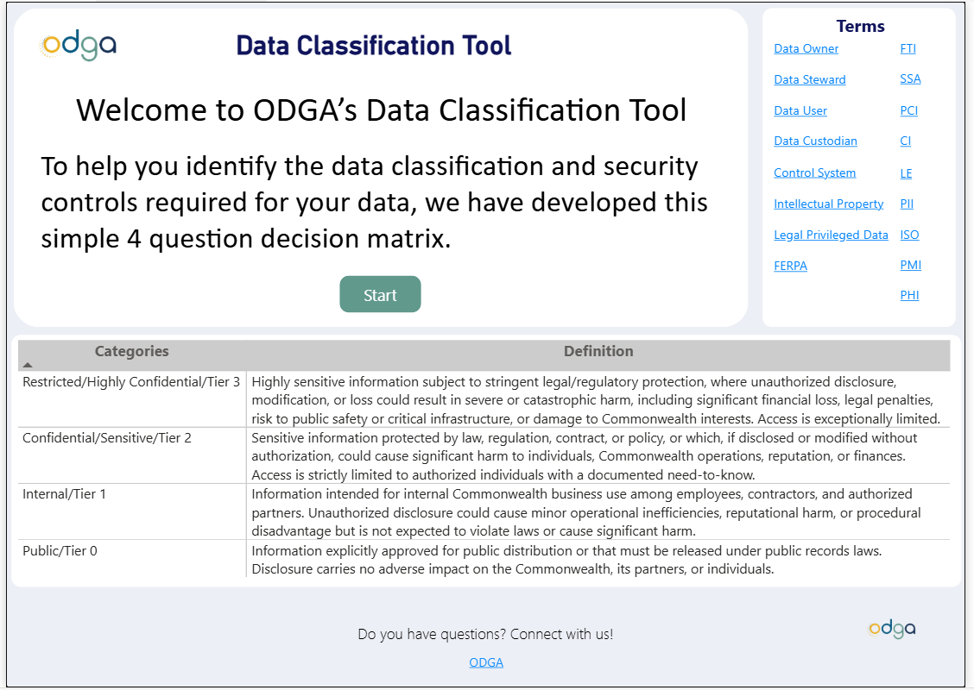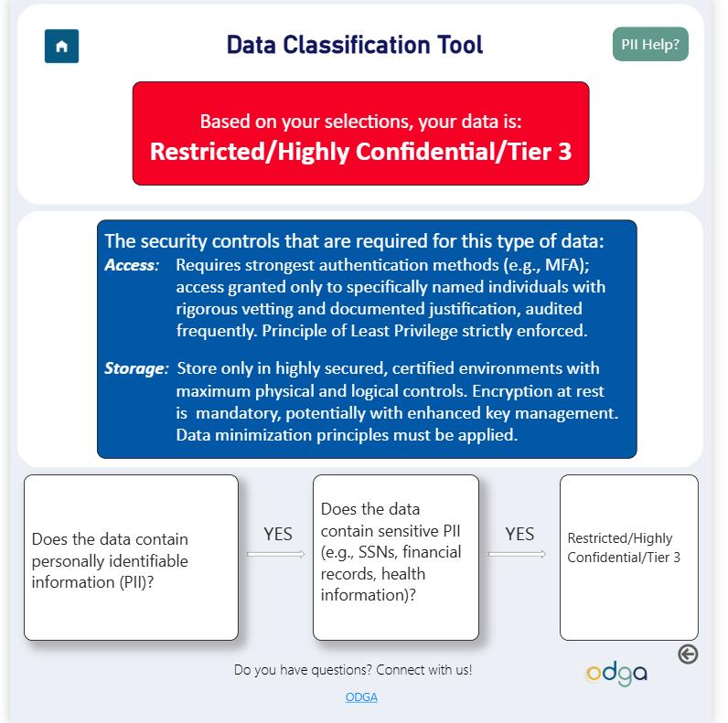

Above: Images of the ODGA Data Classification Tool

Knowledge Sharing Through Speaking Engagements
The ODGA team has worked to share knowledge with state agencies and the greater Commonwealth of Virginia through several speaking engagements, including about the following topics:

- Structuring data for use in AI
- Data protection lessons from industry data breaches
- Data governance for impactful decision making/use in AI
- Basic data concepts
- Data stewardship
- Data governance and records retention
- The Virginia Government Data Collection and Dissemination Practices Act
- Data analytics

Data Governance Maturity Contest
In spring and summer 2025, ODGA hosted its first-ever Data Governance Maturity Contest, designed exclusively for members of the Commonwealth Data Trust. This initiative provided an opportunity for participating agencies to assess and showcase their progress in advancing data governance.
Commonwealth Data Trust members submitted comprehensive information regarding their data governance programs, which was evaluated by the ODGA team using a detailed awards rubric. This rubric measured progress across key areas, including policy development, training and overall governance practices.
The winners of the ODGA Data Governance Maturity Contest include:

Large Agency Category

1st Place: Virginia Department of Behavioral Health and Developmental Services

2nd Place: Virginia State Police

3rd Place: Virginia Department of Taxation

Medium Agency Category

1st Place: Virginia Department of Education

2nd Place: Virginia Department of the Treasury

Honorable Mentions:

Virginia Department of Health

Virginia Department of Environmental Quality

Commonwealth Data Trust (CDT)
The Commonwealth Data Trust (CDT) remains a cornerstone of ODGA’s mission to foster secure, efficient and collaborative data-sharing across Virginia. As a legally compliant and secure framework, the CDT enables standardized, scalable data exchange between agencies, localities and public institutions through common protocols and consistent agreements. Over the past year, the CDT welcomed four new members — the Virginia Department of Taxation, the Virginia Department of Deaf and Hard of Hearing, the Virginia Behavioral Health Commission and the Virginia Department of Accounts — bringing the total number of participating organizations to 46 as of November 2025.
The CDT continues to reduce the need for costly, duplicative point-to-point data sharing by providing a consistent agreement for Commonwealth organizations. By promoting common rules for data security, privacy and confidentiality, the CDT builds trust among its members while enabling efficient data discovery and analytics across Virginia. The growth and sustained participation highlight the CDT’s value as a critical asset for data-driven decision-making in Virginia.

Commonwealth Data Trust Portal
ODGA successfully developed and deployed the Commonwealth Data Trust Portal, a custom application that transformed the state's data sharing and collaboration processes. This enterprise-grade solution addresses the critical challenge of managing complex interagency and external partner data agreements, which previously relied on inefficient manual processes conducted through email correspondence and paper-based workflows. The legacy system created significant administrative burden, delays in processing requests and challenges in maintaining compliance and audit trails across multiple stakeholders. Recognizing the need for modernization, our technical team embarked on a multi-year initiative to create a centralized, automated platform that would streamline operations while enhancing security and transparency.
Built entirely by internal ODGA development staff, the portal represents a sophisticated integration of cutting-edge technologies and industry best practices. The solution utilizes a modern technology stack, including Microsoft's .NET framework for robust backend API development paired with Angular for a responsive, dynamic frontend user experience. This solution ensures optimal performance, maintainability and cross-platform compatibility. Deployed within the VITA Azure environment, the application leverages Azure's comprehensive suite of services, including SQL Database for robust data management, Storage Accounts for secure file handling and Key Vault for enterprise security standards. The platform features sophisticated integrations with VITA's OKTA authentication system for secure single sign-on capabilities and BOX document management for streamlined digital signature workflows, while utilizing Azure DevOps for continuous integration, version control and automated deployment processes that meet government security standards.
This digital transformation initiative has delivered substantial operational improvements and strategic benefits for the Commonwealth. The portal provides a centralized platform where agencies and external partners can seamlessly join the data trust, update agreements, request data from providers, execute digital non-disclosure (NDA) agreements and manage all aspects of the data sharing lifecycle through an intuitive web interface. The automated workflow system has eliminated manual email-based processes, implementing intelligent notifications and alerts that guide stakeholders through each step of the approval process while maintaining complete audit trails and compliance documentation. This modernization effort has significantly reduced processing times, enhanced data security, improved inter-agency collaboration and established a scalable foundation that supports the Commonwealth's expanding data-sharing initiatives while positioning Virginia as a leader in government digital innovation. This platform is the foundation for document assembly in the Commonwealth for other agencies to utilize. The platform also acted as the central NDA repository for the SUDA platform.

Commonwealth Data Trust Membership
Members of the Commonwealth Data Trust include:
Secretary of Administration
- Department of Human Resource Management
- Virginia Information Technologies Agency
Secretary of Agriculture and Forestry
- Department of Forestry
Secretary of Commerce and Trade
- Department of Small Business and Supplier Diversity
- Virginia Economic Development Partnership
- Virginia Tobacco Region Revitalization Commission
Secretary of Education
- Virginia Community College System
- Department of Education
- State Council for Higher Education for Virginia
Secretary of Finance
- Department of the Treasury
- Department of Taxation
- Department of Accounts
Secretary of Health and Human Resources
- Department for Aging and Rehabilitative Services
- Department of Behavioral Health and Developmental Services
- Department for Blind and Vision Impaired
- Department of Health
- Department of Medical Assistance Services
- Department of Social Services
- Office of Children’s Services
- Department of Deaf and Hard of Hearing
Secretary of Labor
- Virginia Employment Commission
- Department of Labor and Industry
Secretary of Natural and Historic Resources
- Department of Conservation and Recreation
- Department of Environmental Quality
- Department of Wildlife Resources
Secretary of Public Safety and Homeland Security
- Commonwealth of Virginia Homeland Security Division
- Department of Criminal Justice Services
- Department of Corrections
- Department of Emergency Management
- Department of Fire Programs
- Department of Forensic Science
- Department of Juvenile Justice
- Department of State Police
Secretary of Transportation
- Department of Aviation
Secretary of Veterans and Defense Affairs
- Department of Veterans Services
Localities
- Chesterfield County
- City of Virginia Beach
Other
- Virginia Association of Recovery Residences
- Virginia Works
- Office of the State Inspector General
- OMNI Institute
- Virginia Hospital and Healthcare Association
- Virginia Innovation Partnership Corporation
- Joint Commission on Healthcare
- Rappahannock Community Services Board
- Virginia Behavioral Health Commission

Citizen Engagement

Virginia Open Data Portal (ODP)
The Virginia Open Data Portal (ODP) is an ODGA-managed repository for state public datasets. The platform increases government transparency for Virginia residents by providing access to state datasets. Within the portal, users can view stories and dashboards, create visualizations, filter data and access it via application programming interfaces (APIs) to build solutions in web and mobile applications. Agencies can publish data on the platform at no cost.
In November 2024, the platform hosted 10,000 datasets and resources for users. As of November 2025, that number has grown to 31,519 datasets and resources hosted on the platform.
In 2025, there was a concerted effort to bring more attention to the platform, especially among educational institutions in Virginia. In 2024, page views to the platform were 20,000-40,000 monthly. In 2025, page views to the platform grew to 40,000-55,000 monthly.
The ODP is also a valuable resource to Virginia’s higher education institutions. Two professors at William & Mary’s Raymond A. Mason School of Business have utilized the ODP as an opportunity for learning in their machine learning and database classes. In these classes, datasets on the portal are assigned for important projects geared toward data cleaning, analysis, findings interpretation and communication.
In the database class, students are tasked with selecting a topic and sourcing relevant datasets from the ODP to support their research and analysis. Students consolidate data from multiple sources, clean it and put all the data into the same format. Then students are tasked with looking for missing values and other data quality issues. After the data is cleansed and consolidated, the students are instructed to build a previously designed data warehouse by connecting Alteryx with MySQL to automatically create the tables and feed them with the corresponding data. Students focus on decision making with the data and create a dashboard using Tableau. They answer prompts with the data that they create using the dashboard and their analysis.
In the machine learning class, students utilize the ODP to develop predictive models using real-world data. Students perform data cleaning, exploratory data analysis (EDA) and feature engineering. They also conduct model training in DataCamp Workspaces, applying techniques such as linear regression, logistic regression and k-nearest neighbors. Students use cross-validation and evaluation metrics like accuracy, precision, recall and mean squared error (MSE) to assess model performance.

Virginia Datathon
The Virginia Datathon is an ODGA-hosted competition in which teams are given public Commonwealth data to solve a challenge that Virginians are facing. Started in 2014, the event not only brings together state agencies, but has expanded to include students, localities, non-profits and the private sector. These groups leverage technology and data to develop innovative solutions addressing complex problems. The Virginia Datathon is the first of its kind and the longest running state hackathon event.
The April 2025 Virginia Datathon theme was “Leveraging Data for Smoother Transportation.” The Virginia Open Data Portal (ODP) powered the 2025 Virginia Datathon. Datathon teams accessed open data to develop innovative solutions to address the theme. On top of the plethora of datasets already available through the platform, 377 datasets were sourced for the event.
Several agencies provided datasets for the event, including: the Virginia Department of Rail and Public Transportation (DRPT), Virginia Department of Transportation (VDOT), Virginia Department of Motor Vehicles (DMV), Virginia Office of Intermodal Planning and investment (OIPI), Virginia State Crime Commission, Virginia Department of Education (DOE), Virginia Works/Department of Workforce Development and Advancement (DWDA) and the Port of Virginia. Event participants were from a diverse range of organizations, including Varina High School, William & Mary, the City of Norfolk, Virginia Military Institute, Miles E. Godwin High School, Virginia Department of Motor Vehicles (DMV), Deep Run High School, Virginia Commonwealth University, the Virginia Department of Behavioral Health and Developmental Services (DBHDS), Virginia Polytechnic Institute and State University, and various private sector organizations.
Participants provided well-thought-out solutions and covered a diverse range of topics. Winning solution included the following:
1st Place: Team Backseat Analysts
- Analyzed 1.2 million Virginia crash records (2016–2025) to map high-fatality zones and identify contributing factors
- Built an interactive dashboard and deep learning model to predict crash severity, supporting real-time alerts and infrastructure planning
2nd Place: Team Manta Rays
- Developed a smart routing tool for cyclists that prioritizes safety using crash and traffic data
- Algorithm assigns danger scores to road segments and integrates live traffic feeds, promoting safer, more confident cycling in Richmond
3rd Place: Team Neural Nexus
- Created predictive model and heat map linking crash data with transit access to identify underserved, high-risk areas
- Tool aids state agencies in forecasting risks, guiding infrastructure investments and improving road safety planning

